Management of Conflict Leadership Strategies

1) Conflicts in Project Management can be attributed to Factors that are either:

Technical OR Human
Project Scheduling (Time) Administrative
Technical (Quality) Human/Diversity Resource Management
Financial (Cost) Personality/Opinion Differences

2) Conflicts IMPACT can be controlled to be either Positive(+) or Negative(-)
Promote Changes Productivity
Open communication & Unite Staff Morale &
Promote Cooperation/Innovation & Synergies Teamwork /Trust Affected

3) CONFLICT LEADERSHIP STRATEGIES
Complete the following table with the correct number for each of the five conflict handling strategies:
Number CONFLICT RESOLUTION STRATEGIES
#___ MUTUAL BENEFIT COOPERATION (OUTCOME, WIN/WIN/WIN)2
#___ COMPETITION (IMPOSING OWN VIEWPOINT, WIN/LOSE)
#___ COMPROMISE ("BAZAAR", WIN/WIN)
#___ SMOOTHING (PARTIAL RETREAT & SUPPORT, LOSE/WIN)
#___ SURRENDER (LOSE/LOSE)
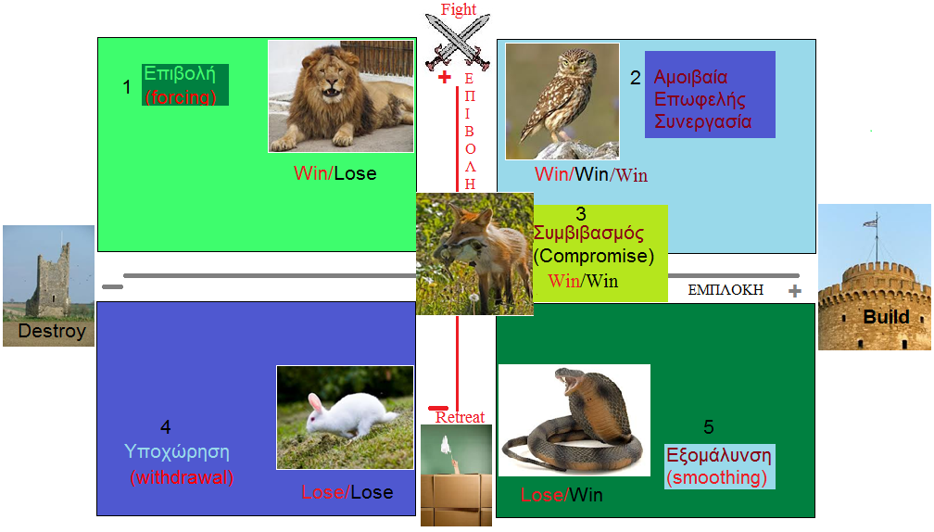
VISIBLE -----------------------------------------→←-----------------------------------------INVISIBLE

4) In each of the following cases indicate the number of the most adequate strategy that can be used to resolve a conflict:
#___ Α. When requested to perform an unpleasant task, I prefer to delay its enforcement forever rather than follow orders without having had a prior discussion

#___ Β. If there is a difference of opinion, I impose my view and don’t cede any ground

#___ C. If there is disagreement, I prefer to arrive at an agreement on intermediate positions rather than totally retreat

#___ D. When there is a difference of opinion, I prefer to work on our differences with the other person, rather than to try to convince him that I'm right and he is wrong

#___ Ε. Sometimes it is easier to agree with the «fittest " avoiding to make comments on a controversial issue

5) Conflict Resolution Strategy Conclusion (Suggested Best to Worst)
Select Strategy in accord with the Mission Statement/ Culture/ Objectives and Strategy of your firm / Country (e.g., Greece’s Negotiation with the Lenders).
2 MUTUAL COOPERATION Favoring a Long Term Mutual Benefits
5 STANDARDIZATION Long Term Benefits after Initial Retreat
3 COMPROMISE For immediate cooperation (Stability) with fewer benefits
1 COMPETITION Only for short / medium-term benefits
4 RETREAT To select an alternative better or worse cooperation (wishful thinking)

Solutions to Exercises 3 & 4:
Exercice3: 2, 1, 3, 5, 4
Exercise4: 5A, 1B, 3C, 2D, 4E

