EXERCISE 3
BASIC STATISTICS IN HYDROLOGY
- In the following table the mean yearly precipitation is given for a station for a period of 10 years. If the mean is m= 979,2 mm, find standard deviation s. Then, calculate the probability than in one year we will have (a) rainfall larger than 1200 mm (b) smaller than 800 mm (c) rainfall between 800 and 1200 mm. What is the probability that in two consequent years we will have precipitation smaller than 800 mm or larger than 1200 mm?
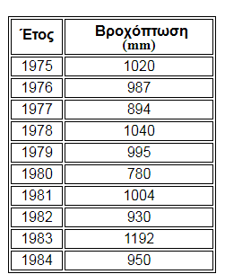
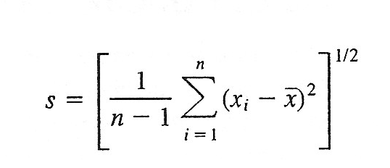

Suggestion: insert in the table and calculate the columns: x_{i} – m, και (x_{i} – m)²

- Given that the mean annual discharges of a river for a period of 30 years are following normal distribution with m = 22,4 m³/s and standard deviation s = 6,2 m³/s. What are the values of discharge that correspond to recurrence intervals of T = 2,20,200 years. If the 70% of the river water is used for water supply of a nearby town, what is the probability that in one year we will not be able to cover the water needs of the town? (= probability to have mean annual discharge less or equal to 70% of the mean).

