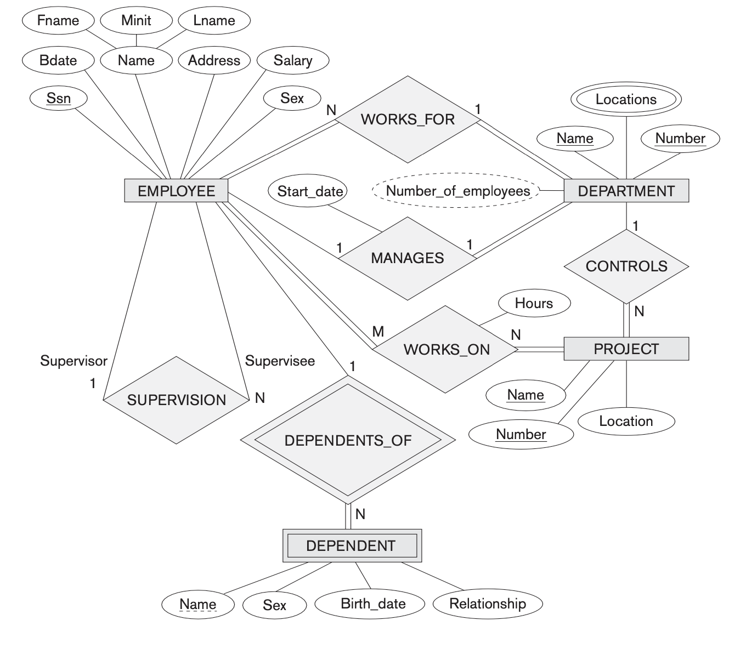

EMPLOYEE : ( SSN, Name, Bdate, Address, Salary, Sex, Dno, Supervisor_SSN )

DEPARTMENT : ( Number, Name, Locations, #Employees, Mgr_ssn, Mgr_Start_Date )

PROJECT : ( Number, Name, Location, Dno )

DEPENDENT : ( Name, Emp_ssn, Sex, Bdate, Relationship )

WORKS_ON : ( Emp_SSN, Proj_Num, Hours )

Foreign key constraint = Ξένο κλειδί

Employee: ( SSN …..
1, ….
2, ….
35, …

Dependent : ( Name, Emp_ssn, ….. )
X , 1
Y , 35
Z , 5

