EXERCISE 2
RATING CURVE CONSTRUCTION AND CALCULATION OF THE FLOOD WATER VOLUME FROM A HYDROGRAPH
1. In station Poros Riganiou 12 discharge measurements have been conducted that can be seen in the next page. Find the relationship between stage, h, and discharge, Q, (rating curve).
2. Based on this rating curve and the stage hydrograph of the next table, sketch the discharge hydrograph and calculate the volume of water that passed through the station within the given time-period (Stage h= 0,4 is considered as base flow -> existed before and after the flood, attributed to the contribution of groundwater).
t (hr) | h (m) | Q tot  (cms) | Q bas  (cms) | Q flood  (cms) | Vol  flood  (m³)
0 | 0.4 |  |  |  | 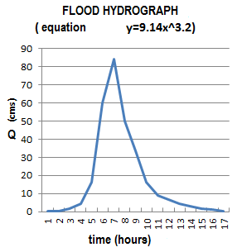
1 | 0.4
2 | 0.6
3 | 0.8
4 | 1.2
5 | 1.8
6 | 2
7 | 1.7
8 | 1.5
9 | 1.2
10 | 1
11 | 0.9
12 | 0.8
13 | 0.7
14 | 0.6
15 | 0.5
16 | 0.4
 |  |  |  | ΣVol=

(Q tot comes from the rating curve. Q bas is the same for all the time period.
Q flood = Q tot - Q bas. Flood water volume, Volflood is calculated by multiplying Qflood by the seconds of an hour (or any other time period given in the time axis – x). The sum of this column is the volume of water that passed from the station within the time covered by the hydrograph.

3. If the catchment has a surface of Α = 240 km² find the active rain (meaning this part of the rainfall that made it to the river and became river flow) for this flood incident.

http://www.geol.lsu.edu/jlorenzo/geophysics/graphing/graphingpart2.html
y = ax^{b} => logy = loga + b*logy
α/α | Stage | Discharge | α/α | Stage | Discharge | α/α | Stage | Discharge | α/α | Stage | Discharge
 | h (m) | Q (m³/s) |  | h (m) | Q (m³/s) |  | h (m) | Q (m³/s) |  | h (m) | Q (m³/s)
1 | 1.35 | 25.3 | 4 | 1.42 | 34.2 | 7 | 1.49 | 40.2 | 10 | 0.87 | 5.4
2 | 0.58 | 1.4 | 5 | 1.19 | 18.0 | 8 | 0.99 | 7.5 | 11 | 0.75 | 3.5
3 | 1.13 | 15.8 | 6 | 1.05 | 10.5 | 9 | 0.63 | 2.1 | 12
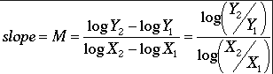
log-log paper
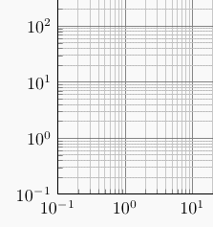

For finding a, check to see where your trendline will meet h =1.

