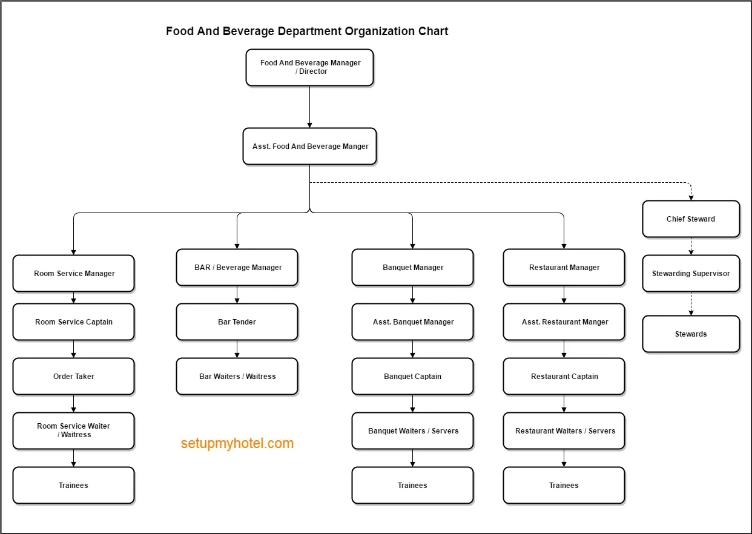
Organization chart for a big hotel

Organization chart for a small hotel
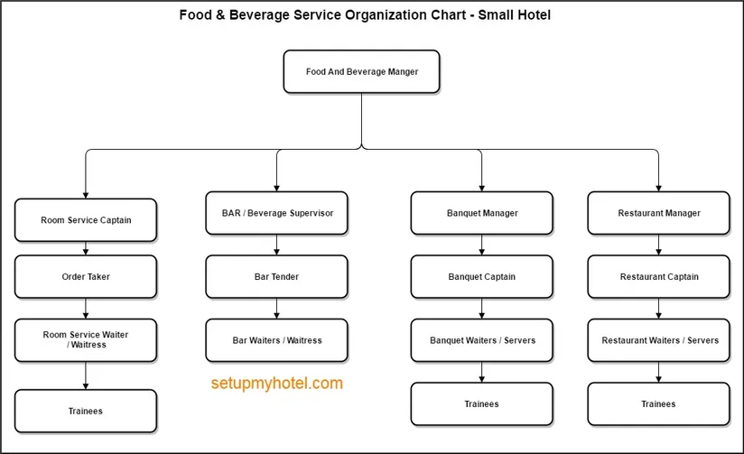

https://setupmyhotel.com/job-description-for-hotels/food-and-beverage-service-job-description/493-f-and-b-organization.html
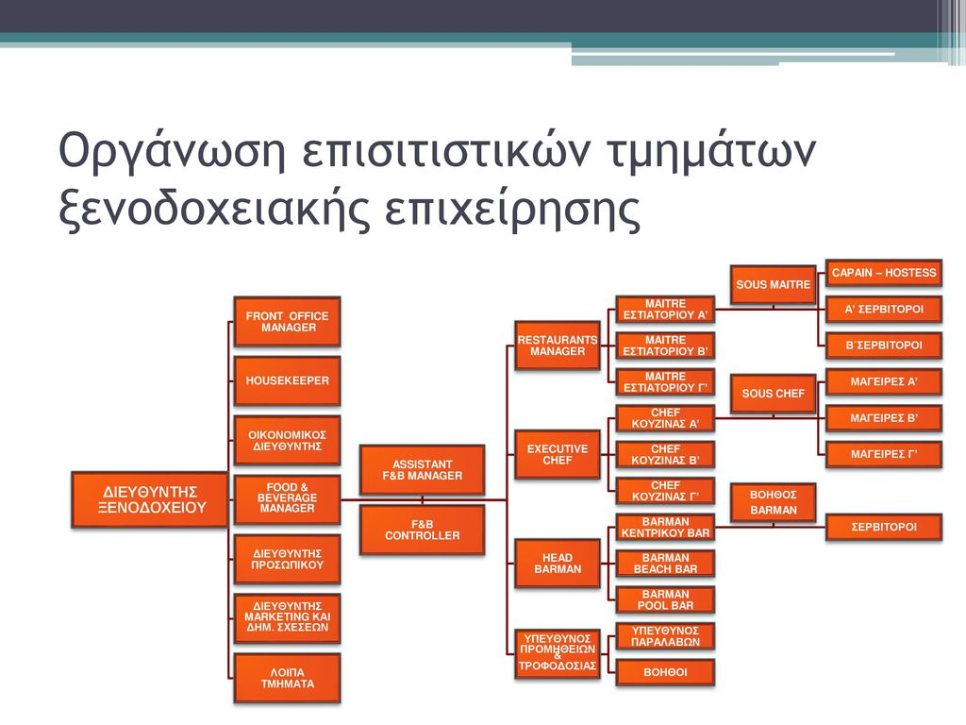
ΕΡΓΑΣΙΑ, ΛΕΟΝΤΙΤΣΗ ΛΟΥΚΙΑ, ΔΙΟΙΚΙΣΗ ΕΠΙΣΙΤΙΣΤΙΚΩΝ ΜΟΝΑΔΩΝ I

