MANNING’S FORMULA

A formula for computing mean velocity and water depth in open channel flow.

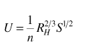

Where

**U**= average velocity (m/s)

**n**=friction factor of the material of the banks (m1/3 s-1)

**R**=hydraulic radius (in m =cross section (Α) / wetted perimeter (Ρ) )

**S**=longitudinal slope of the channel (dimensionless)

Manning’s formula is applicable for steady and uniform flow.

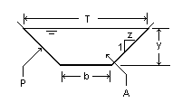

The symbols used in trapezoid channels are (P -> wetted perimeter, A->cross section surface, T ->width of flow, z-> slope of the banks). In most cases the geometry of the channel (b,z,n,S) is known and we want to find V, y. We solve by trial and error. We can start with y=1 and calculate Α,P,R , then V and finally Q, as V*A. If the value we find is not our Q, then we continue with another value for y. We have to be careful with S which enters the formula as m/m (i.e for 1% slope we enter S =0.01, etc).

**EXAMPLE:** Calculate **U** and **y** for Q=5 cms, b=2m, z=1, n=0.015, S=0.5%



