Links μαθημάτων Erasmus studies που διδάσκονται στα αγγλικά στα Ιδρύματα υποδοχής
Για συμπλήρωση του online learning agreement (OLA) https://learning-agreement.eu/
To ΠαΔΑ αναφέρεται στην εφαρμογή Erasmus dashboard ως Panepistimio Dytikis Attikis

Ρουμανία, Sibiu, Lucian Blaga University of Sibiu RO SIBIU01
http://international.ulbsibiu.ro/index.php/university-curricula/#
CURRICULA OF THE "LUCIAN BLAGA" UNIVERSITY OF SIBIU
Faculty of Agricultural Sciences, Food Industry and Enviromental Protection
Ba Studies:
- Biotechnologies for Food Industry
- Control and Survey of Foods
- Engineering and Environmental Protection in Agriculture
- Food Products Engineering
- Hotel, Catering and Tourism Management and Engineering
- Montanology
Ma Studies:
- Food Quality and Safety Assurance
- Management of Modern Food Processing

At the Lucian Blaga University, there is a MANDATORY rule for the Erasmus incoming students, to obtain 12 credits from the 30 credits by choosing some courses from those presented below. Please consider this request by preparing the learning agreement.
Oral Communication Romanian Language - 4 ECTS
Romanian Culture and Civilization - 4 ECTS
Introduction to Accounting and Finance - 4 ECTS
Engineering Essentials - 3 ECTS
Legal Protection of Human Rights at National, European and International Level - 3 ECTS
Text – Theatre – Film. Interdisciplinary Approaches -3 ECTS
Interdisciplinary Coordinates of Bioethics - 4 ECTS
Interactions between the Human Society and Ecological Systems - 4 ECTS
Understanding the Social Environment. Theories, Methods and Practice - 3 ECTS
Biotechnology – An Introductory Course - 3 ECTS
An Introduction to Romanian Orthodoxy in the Context of World Orthodoxy - 3 ECTS

Πορτογαλία, Viano do Castello, IPVC
http://internacional.ipvc.pt/en/node/264 (επιλογή μαθημάτων όχι από 4^{ο} και 5^{ο} εξάμηνο γιατί διδάσκονται σε άλλο μέρος) δηλ επιλογές μαθημάτων μόνο από 1ο,2ο,3ο και 6^{ο} εξάμηνο του προγράμματος σπουδών.
Some classes are tutorial and the Professors teach the classes in Portuguese as well as in English. The practical classes are explained to ERASMUS students in English.
The exams are translated and the students do it in English.
The course is Food Engineering.
The study program:
1st semester
Mathematics 6ECTS
Physics 6ECTS
Chemistry 6ECTS
Biology and Biochemistry 6ECTS
Introduction to Industrial Processes 6ECTS
2nd semester
Food Chemistry Laboratories 6ECTS
Food microbiology laboratories 6ECTS
Sensory analysis and rheology laboratories 6ECTS
Unit Operations 6ECTS
Algebra and Statistics 6ECTS
3rd semester
Dairy Technologies 6ECTS
Dairy Quality Analysis and Control 6ECTS
Wine and other Alcoholic Beverages Technologies 6ECTS
Analysis and Quality Control of Wine and Other Alcoholic Beverages 6ECTS
6th Semester
Food Process Design 6ECTS
Treatment of Effluents and Waste 6ECTS
Food Safety Management Systems 6ECTS
Emerging coatings and technologies 6ECTS
Industry and Food Innovation 6ECTS
Project in Food Engineering 6ECTS

Πολωνία, Warmia Mazury in Olsztyn

Course Catalogue - Faculty of Food Sciences (uwm.edu.pl)
Warmia Mazury Olsztyn/Poland http://www.site.uwm.edu.pl/en/study-at-uwm/course-catalogue/course-catalogue-faculty-of-food-sciences

Λιθουανία, Klaipeda state university of applied science (09)
https://www.kvk.lt/en/erasmus/incoming-students/subjects-in-english/faculty-of-technology/

Ουγγαρία, Szeged
http://www2.u-szeged.hu/erasmus/kurzusok/2021_2022/20_12_20_courses_faculty_of_engineering_erasmus_2021_2022.pdf

Oυγγαρία Debrecen
BSc https://mek.unideb.hu/en/node/461, https://edu.unideb.hu/p/food-engineering-bsc
MSc https://mek.unideb.hu/en/node/462, https://edu.unideb.hu/p/food-safety-and-quality-engineering-msc

Βλέπε: curriculum και όλα τα μαθήματα διδάσκονται στα αγγλικά (θυμίζω ότι τα μονά 1,3,5 προσφέρονται στο χειμερινό εξάμηνο και τα ζυγά 2,4,6 στο εαρινό τους εξάμηνο)

Γαλλία, AGRO3 (Lille, Lyon, Toulouse)
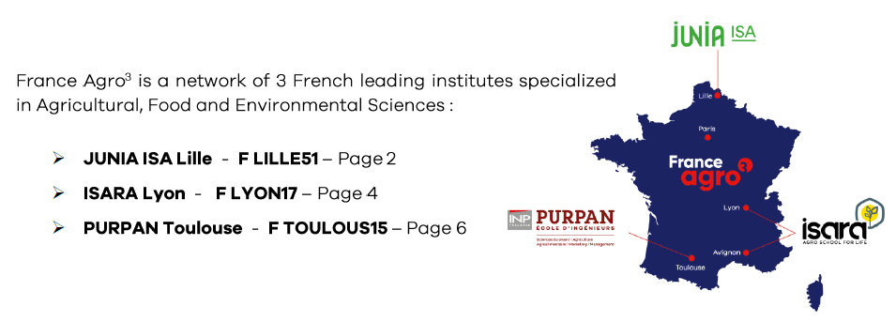
Isa Lille: Master of Food Science: https://www.isa-lille.com/academics/master-programs/food-science/ | 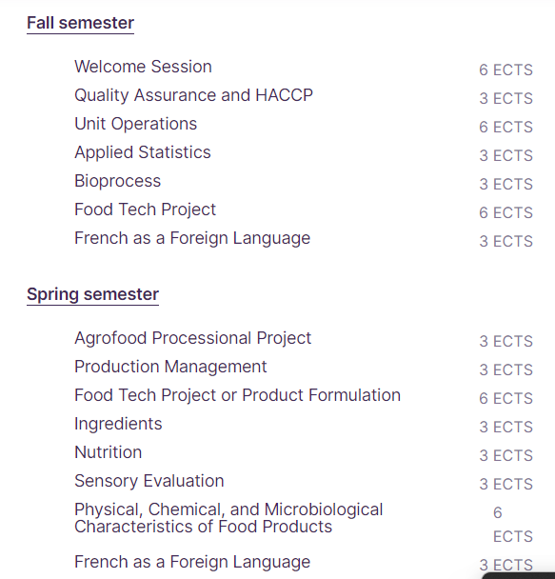

Isara Lyon: Food Sciences and the management of food industries: https://isara.fr/en/how-to-apply/exchange-programmes/academic-semesters/food-sciences-and-the-management-of-food-industries/
Toulouse: International Bachelor certificate (IBC) courses: https://www.purpan.fr/wp-content/uploads/2021/01/exchange_student_purpan_2021-2022_courses-ibc-v1.pdf
Toulouse: Global Semester (spring only): https://www.purpan.fr/wp-content/uploads/2021/01/exchange_student_purpan_2021-2022_courses-global-semester-v1.pdf

Ισπανία, Βαρκελώνη UPC
https://esab.upc.edu/ca/mobilitat/incoming-students-1/llengues

Ισπανία, ELCHE, UMH Universitata Miguel Hernandez
https://www.umh.es/contenido/Estudios/:tit_g_274_K1/datos_en.html

Ισπανία, Leon

https://www.unileon.es/files/English%20Friendly%202019-2020%20%2830-07-19%29%20Ingl%C3%A9s.pdf.
Περιεχόμενο μαθημάτων Leon (στα Ισπανικά) https://www.unileon.es/estudiantes/oferta-academica/grados/grado-en-ciencia-y-tecnologia-de-los-alimentos/plan-estudios?id=0107126&cursoa=2022

Ισπανία, University of Extramadura, Bedajoz

Tουρκία, Yeditepe University, Kωσταντινούπολη -Istanbul

Γαλλία - Angers -ESA (Ecole superieure d agricultures) F ANGERS08
Note that prior to each programs you will have 2 weeks of French as a Foreign Language for 4 ECTS which are not included in the total number ECTS

FOOD IDENTITY  or  WINE IDENTITY  FALL SEMESTER | FOOD IDENTITY track (Master 1 level)
 | FI-11-TER - Concepts of local and traditional food products | 5
 | FI-12-PRO - Processing of traditional food products | 7
 | FI-13-QM - Quality management and methods of characterization of food products | 8
 | FI-14-BR – Bibliographical research | 5
 | TOTAL ECTS = | 25
 | WINE IDENTITY track (Master 2 level)
 | Please choose one of the following options*:  *Option 1: VM2-WINEID–TER Values of food products (Master Food Identity courses + specific project) from mid-September until mid-October [written exam]  *Option 2: VM2-WINEID-ARP – Applied research project (GRAPPE research unit) from mid-September until end of February [written report + oral defense] | 10
 | VM2-WINEID-AVT – Understanding the added values of terroir-driven wines – starting mid-October | 10
 | VM2-WINEID-FCS – Analyzing the terroir system and identity of wine regions – starting mid-October | 5
 | VM2-WINEID-S3 – Terroir factors and wine tasting – starting mid-October | 5
 | TOTAL ECTS = | 30

Πληροφορίες και Erasmus αιτήσεις https://olage.groupe-esa.com/international-exchange-students-programs/exchange-semesters/exchange-student και επιλέγουμε με κλικ από τα παρακάτω
BACHELOR LEVEL: Vocational Bachelor (Year 3):
- Plant Production – Minor in Plant Breeding and Experimentation (program description) – SPRING SEMESTER ONLY
- Innovation and Transformation of local food products (program description) – SPRING SEMESTER ONLY
Δηλ ο κατάλογος μαθημάτων εμφανίζεται στις σελ 2 και 3 αλλά τεχνικά δεν ανταποκρίνεται ο σύνδεσμος file:///C:/Users/user/AppData/Local/Temp/2021-22%20Incoming%20Mobility_Undergraduate%20programs.pdf

Γερμανία, Hochschule Trier, Food Technology

A Προσφέρονται στα Αγγλικά τα παρακάτω μαθήματα από το πρόγραμμα σπουδών
Summersemester:
• Unit Operations (Emulsification, Filtration, Crystallisation): In this subject student need to give two presentations on subjects concerning unit operations in Food Science. The subjects are selected on their own. One presentation is usually held in German, the second one in English. If a student from abroad is also joining, both presentations will be held in English
• Applied statistics in Sciences (Seminar will be held when more than 3 students are interested).
• Produktdesign (both: German and English possible. Comparable with unit operations)
- Food Science in everyday life (Seminar)

Wintersemester:
• Applied statistics in Sciences (This subject is now given in German. If more than 3 students from abroad are interested, additionally a seminar will start in English)
• Food Science in everyday life (Seminar)
All other modules are taught exclusively in German.

Β Ειδικό νέο πρόγραμμα για ξένους φοιτητές (εαρινό εξάμηνο)
Study Semester "Food Economy and Process Technology" (hochschule-trier.de)
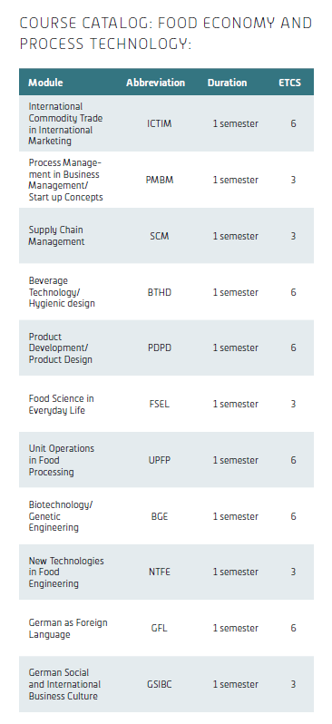

Γαλλία, Lille – Polytech IUT F LILLE 103 (ήταν 01)

Βέλγιο, Odisse University of Applied Science, Faculty (cluster): Biotechnology, Dept (Programme): Agro- and biotechnology) at Campus Sint-Niklaas
Συνδυαστικά: Πτυχιακή 9ECTS και πρακτική 15ECTS (συνήθως σε βιομηχανία τροφίμων)
The only Erasmus courses Odisee programme can offer is in a traineeship programme and/or bachelor’s thesis (in enlgish).
The courses below are taught in Local Language:
Which campus offers what course: depends on the course… if they are part of the chemistry (or other technology) program, they are organized in Ghent.
If they are part of the agro- and -biotechnology program, they are taught in Sint-Niklaas.
From the cluster (= faculty) of (Bio)Technology all programs except Agro- and Biotech are located in Ghent
Also a lot of courses are also offered “in distance education”, which means that they are in some way recorded and digitally offered, so students (sometimes) do not need to physically attend classes (with the exception of lab classes, of course).
In any case, although it takes about an hour to travel from the campus of Ghent to the campus of Sint-Niklaas, there is very good public transport, so occasionaly a course on another campus shouldn’t be a problem (of course, only occasionally).

Ισπανία Elche St Miguel
ELCHE/Spain https://internacional.umh.es/files/2022/05/Courses-taught-in-English_22_23-1.pdf

Links μαθημάτων Erasmus studies που διδάσκονται στην τοπική Γλώσσα:

Ισπανία, Βαρκελώνη
Πλήρες πρόγραμμα σπουδών στα Ισπανικά (ή Καταλανικά)
https://www.upc.edu/en/bachelors/food-engineering-castelldefels-esab

Ισπανία, Μαδρίτη, Juan Rey Carlos (μόνο στα Ισπανικά)

https://www.urjc.es/estudios/grado/584-ciencia-y-tecnologia-de-los-alimentos#plan-de-estudios

Ισπανία Leon
The best choice for your students would be to attend the courses in Spanish (study plan: https://www.unileon.es/estudiantes/estudiantes-grado/oferta-de-estudios/planes?titula=0107). Therefore, it would be strongly recommended that your students get a Spanish language certificate, such as B1 level, in order to follow properly the lectures

Γερμανία, Trier
https://www.hochschule-trier.de/hauptcampus/bauen-plus-leben/fachrichtung-lebensmitteltechnik/studium/studiengaenge/lebensmitteltechnologie-beng

Γερμανία, Berliner Hochschule für Technology – Lebensmitteltechnology (BSc)
https://www.bht-berlin.de/b-lt

