The Aging Eye: Problems That Affect Acuity and Contrast Sensitivity

You are not logged in.

Introduction

When I was asked to prepare courses on the aging eye, I was reminded of the book by that name written some forty years ago by R. A. Weale, Head of the Department of Physiological Optics at the Institute of Ophthalmology in London (1). In this book, Weale took a broad approach to the age-related changes that occur in the eye, including ocular morphology; refraction; visual thresholds; spatial and temporal resolution; spectral sensitivity; and color vision.
In my course on this subject, I will follow Weale's lead and also take a broad approach to the effects of aging on vision and the eye. Although optometrists currently tend to be concerned mainly with disease-related conditions that can cause severe vision impairment or blindness, there are many relatively subtle - but nevertheless important - age-related changes that affect almost everyone beyond the age of 45 or 50-years.
This course will focus on changes in refractive error, retinal illumination, visual acuity, contrast sensitivity, problems with the lacrimal system, and age-related cataracts. Although cataracts have traditionally been considered as a major cause of age-related vision loss, it is fortunate that in countries where the current 'no-stitch' cataract surgery with phaco-emulsification, followed by the implantation of an IOL is available -- including the United States, Canada, England, Australia, and New Zealand -- cataracts may be considered as a 'temporary' loss of visual acuity.

Presbyopia
The most obvious of the "less-threatening" age-related changes in vision is presbyopia, which usually becomes evident by 40 to 45 years of age. As shown in Figure 1, the near-point of accommodation gradually moves outward from about 10 inches (20 cm) at age 40, to 12 inches (30 cm) at age 45, and 16 inches (40 cm) at age 50 years.

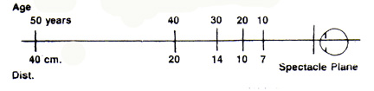
Figure 1. Near-point of accommodation as related to age.

Derived from the Greek presby and ops meaning old-age sight, presbyopia occurs because the eye’s lens gradually loses its ability to change shape when acted upon by the ciliary muscle - the smooth muscle within the ciliary body that surrounds the lens.

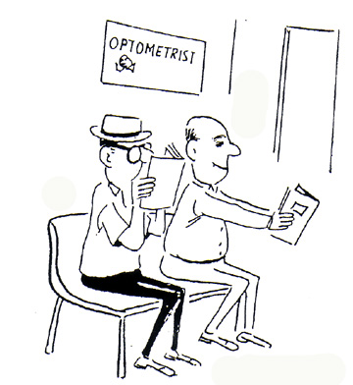
Figure 2. Two strategies for dealing with presbyopia. This is one of the many ‘Eye Doctor’ cartoons collected by Prof. Henry Hofstetter, Indiana University School of Optometry. It appeared in the Aug.18, 1968 issue of The Optical Journal and Review of Optometry.

Determining the Power for a Presbyope's Reading Addition
Either (or both) of two methods can be used to determine the power of the add power to be given in the form of reading glasses, bifocals, trifocals, or progressive addition lenses.
1. On the basis of the near-point of accommodation.
With the patient wearing his or her correction for distance vision, the near-point card is placed on the reading rod at a distance of 40 to 50 cm, and it is gradually moved inward until the patient reports that the 20/20 (6/6) letters begin to blur. The near-point of accommodation, expressed in cm, is converted to the amplitude of accommodation by means of the formula:
Amplitude of accommodation = 40/near point of accommodation
For a near-point of accommodation of 10 cm, the amplitude of accommodation would be: 40/10, which equals 4.00 D. When the amplitude of accommodation has been measured, the reading addition is determined as the amount of plus lens power that will require the patient to use only one half of his or her amplitude.
2. On the basis of the binocular crossed-cylinder finding.
The Jackson crossed-cylinders (typically with plus and minus 0.50 D powers) are placed in the phoropter with the minus axes in the 90-degree position, and the patient views a crossed-cylinder grid (Figure 3) under very low illumination at a distance of 40 cm. The test is begun with +1.00 D lens power (combined with the subjective lens power) more than the patient has currently worn for near vision. For example, if the patient has worn no near-point addition, the starting added power is +1.00 D; and if the patient has been wearing a bifocal addition, the additional power would be +1.00 D more than the currently worn addition.

Figure 3. The crossed-cylinder grid.

The patient is asked to report which lines are darker or more distinct: those going up-and-down (vertical) or those going across (horizontal). The expected answer is “up-and-down,” in which case the plus power in the phoropter is binocularly reduced, 0.25 D at a time, until the patient reports that the two sets of lines are equally distinct, or the “across” lines are more distinct than the “up-and-down” lines.
Modification of the Tentative Add Power
Once the tentative addition power has been determined, it may be modified by means of: (a) the results of the negative and positive relative accommodation (plus and minus to blur) tests; and/or (b) the patient’s desired working distance.
1. The relative accommodation tests.
With the near-point card at the 40 cm distance and the tentative addition in place, the examiner asks the patient to keep the bottom line of letters in sharp focus, and to report when the bottom line of letters begins to blur, as plus lens power is added, 0.25 D at a time. Similarly, the patient is asked to keep the letters in sharp focus as minus lenses are added, 0.25 D at a time. The plus-to-blur and minus-to-blur findings are recorded as the amount of relative plus lens power and minus lens power from the desired add power, respectively, required to blur the bottom line.
The expected result is for the two findings to be equal, or for the plus-to-blur to be slightly higher than the minus to blur; for example, +1.00 D and -0.75 D.
2. The patient’s desired working distance.
gain, with the near-point card at 40 cm and the tentative addition in place, the patient is asked to report when the bottom line of letters begin to blur, as the card is moved farther away on the reading rod. The finding is recorded as the position of the card in cm or inches.
The card is again placed at the 40 cm distance, and the patient is asked to report when the bottom line of letters begin to blur as the card is moved toward the patient. The position of the card when this happens is recorded. The card is then moved to a position halfway between the near and far positions, and the patient is asked whether this is his or her desired reading distance. This test may also be performed out-of-phoropter in a trial frame.
The typical patient will require a reading add of +0.75 D or +1.00 D at age 40 or 42, but possibly at an earlier age for a hyperopic patient, or at a later age for a myopic patient, depending upon the amount of myopia or hyperopia. The power of the addition will typically increase to between +2.25 D and +2.50 D by the age of 54 or 55 years.
The Effects of Pupil Size and Anisometropia
Occasionally an optometrist encounters a patient over age 50 who has never worn glasses or contact lenses, but has no difficulty reading small print at the 40 cm distance. This mystery can often be solved by checking the patient’s pupil size. If the pupil diameter is no more than 2 or 3 mm, the patient’s depth of field is sufficiently large to provide clear vision at a much closer distance than with a larger pupil (the smaller pupils create a ‘pseudo-pinhole’ effect).
Another mystery sometimes occurs when an ‘over 50’ person who has never worn glasses or contacts is able to read the small letters on both the distance and near acuity charts. In this case, the patient might have uncorrected anisometropia and is using one eye for near and the other for distance. I once examined a patient whose refraction was right eye (OD) +0.50 D and left eye (OS) -1.50 D. He wondered why other people his age all were wearing glasses for reading when he could read easily without glasses!
Reading Glasses, Bifocals, Trifocals, or Progressive-Addition Lenses?
Many emmetropes are understandably reluctant to wear glasses in any form because they believe that glasses are a sign of ‘old age.’ These ‘reluctant presbyopes’ will often insist on having reading glasses only so they won’t have to appear in public wearing glasses. But, once they have encountered the problem of having to remove their glasses for distance vision, many patients are willing to accept the idea of wearing bifocals or progressive-addition lenses for reading and other near work. This is especially true if they are reminded that they can always remove their glasses for distance vision. A possible alternative, of course, is the use of ‘half-eye’ reading glasses.
As for my own situation - having moderately high myopia, astigmatism, and anisometropia - I wore bifocals for several years, then I switched to trifocals, and later I switched to progressive-addition lenses. When computers began to play an important role in my life, I found that progressive-addition lenses were far superior to trifocals for computer work, as well as for general wear.
Optical Properties of Conventional Multifocal Lenses
Since the original innovation of Benjamin Franklin (who combined the top halves of his distance spectacles with the bottom halves of his reading spectacles into one frame), multifocal lenses have become a regular staple of the prescribing doctor. Several segmented designs are available, including:
- Straight-top or flat-top bifocals/trifocals – the standard design that still maintains some popularity today.
- Round-top bifocals/trifocals – optically similar to straight-top bifocals, but less ‘visible’ cosmetically to the casual observer.
- Executive® bifocals/trifocals – the reading section comprises the entire width (A-size) of the lens. These lenses are useful when the patient demands a full, clear field of near vision in a bifocal; however, they tend to have a thick ridge at the junction between the distance and near sections, and are typically thicker and heavier in design.
- Double-D straight top bifocals – These lenses incorporate an add power at both the top and bottom of the same lens, with the distance component in the center. These are useful as occupational lenses when the patient needs to look upward at close objects.
- Liberty® (Essilor) – a newer design that incorporates a ‘blended’ zone between the distance and the near areas.
Figure 4 shows several types of segmented multifocal spectacle lens designs.

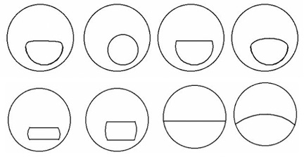
Figure 4: Multifocal spectacle designs. Upper images left to right: Panoptic, Round Top, Flat Top, Curved Top. Lower images left to right): B-Seg (Ribbon), R-Seg (Ribbon), Executive®, Altax®. Images from http://www.eynak.com/ed/00108001.asp

Optical Properties of Progressive-Addition Lenses
Progressive-addition lenses differ from segmented lenses in that progressives have aspheric front surfaces that provide a gradual increase in plus power as the line of sight sweeps downward through a progressive corridor (also referred to as a channel). These lenses typically provide blurred vision on either side of the corridor due to the presence of astigmatism.

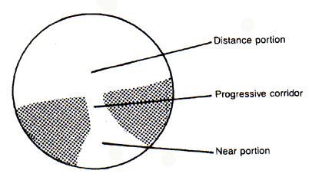
Figure 5. Schematic representation of a progressive-addition lens. The shaded areas represent the presence of varying amounts of astigmatism.

‘Hard’ and ‘soft’ design lenses.
Progressive-addition lenses can be considered as hard or soft designs, on the basis of the length of the progressive corridor and its effect on the induced astigmatism.
A lens having a hard design has a short progressive corridor with relatively large distance and reading areas that are free of unwanted astigmatism, and with the induced astigmatism concentrated into relatively small regions of the lens. With this design, the larger distance and reading areas are provided at the cost of relatively large amounts of astigmatism, which can cause blurred vision and spatial distortion. The Ultravue® lens is an example of a hard design.
A lens having a soft design has a long progressive corridor with relatively small distance and reading areas that are free of astigmatism. The astigmatism is spread over larger areas of the lens at the expense of smaller astigmatism-free distance and near areas. The Varilux 2® is an example of a soft design.
Multidesign lenses.
Borish, Hitzeman and Brookman (2) found that younger presbyopes tend to prefer lenses having a soft design; whereas older presbyopes show about equal preference for lenses having hard and soft designs. Because soft progressive-addition lenses tend to be preferred by presbyopes who require relatively low addition powers, and hard designs tend to be preferred presbyopes who require higher addition powers, multidesign lenses having soft designs in the lower add powers and hard designs in the higher add powers were introduced.

The first multidesign lens to be introduced was the Varilux Infinity®, in 1988, which has individual designs for each add power from +0.75 D to +3.00 D. This was followed in 1993 by the Varilux Comfort®, described by the manufacturer as a multidesign lens having a high and wide reading area and a soft, usable periphery. Other multidesign lenses include the American Optical Pro-15® and Pro-16® lenses, the Silor Adaptor No-Line®, and the Kodak progressive lens. Newer designs that incorporate front and back surface asphericity to decrease induced astigmatism include the Divinity® and Visio® (Essilor) progressive lenses.

VDU progressive-addition lenses.
Horgen, et al., (3) conducted an investigation of the use of progressive-addition lenses that were especially designed for use with computer screens (visual display units - VDUs). Subjects for the study were four groups of VDU users, each consisting of approximately 40 VDU workers.

Subjects filled in a questionnaire concerning visual conditions, working conditions, discomfort, the status of the their optical corrections, etc., before the investigation began and at periods of 6 months and one year. VDU lenses used in the study were the Interview® (Essilor), Gradal RD® (Zeiss) and Technica® (American Optical).
The subjective evaluation of the area of clear vision and overall satisfaction were significantly improved for wearers of Interview® and Gradal RD® lenses. Horgen, et al., concluded:
"Lens designs that cover viewing distances from near out to approximately 2 meters work well compared to lens designs trying to cover a greater range of clear vision. When task analysis shows that single-vision correction may be used, this is still an acceptable solution."
Occupational progressive lenses.
Sheedy and Hardy (4) used a Rotlex Lens Analyzer to determine the optical properties of seven different designs of occupational progressive lenses (OPLs) intended for a patient requiring a +2.50 D add. Lenses used were: AO Technica®, Cosmolit Office®, Essilor Interview®, Hoya Tract®, Shamir Office®, Sola Access®, and Zeiss Gradal RD®.
Sheedy and Hardy also described occupational progressive lenses designed to provide near vision in the lower portion of the lens having a wide field of intermediate vision in the lower portion of the lens and farther intermediate vision at the top of the lens. They emphasized that the lenses were not intended to meet typical distance viewing needs. The results of their investigation showed large optical differences between the various designs in terms of add powers, their locations, and the zone widths. They concluded:
"The literature and clinical experience support that OPLs are successful at meeting the computer, general office, and other intermediate viewing-distance needs of many patients. However because of the large differences in several OPL designs, patient success can likely be enhanced by selecting the design that best suits his or her viewing needs."
Contact Lens and Intraocular Lens Corrections for Presbyopia
An alternative for presbyopia remediation can be multifocal contact lenses (both rigid and soft designs). However, selection of the right candidate for these lenses is of great importance (e.g., good anterior segment ocular health, larger pupil size to allow both the distant and near components of the contact lens to be utilized, and the ability to insert and remove the lenses safely and effectively). (Figure 6)

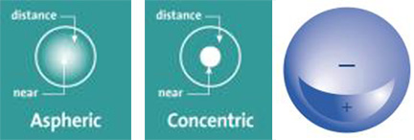
Figure 6. Some multifocal contact lens designs. Left – Aspheric design with near power center, distance power peripheral. Middle – Concentric design with near power center, distance power peripheral. Right – Segment design with near power in lower segment (+). Images from http://www.allaboutvision.com/contacts/bifocals.htm, and http://www.dankerlabs.com/austil.htm.

Newer intraocular lenses that provide multifocal capability through refractive and diffractive means are also available for elderly patients who require cataract surgery. (Figure 7)

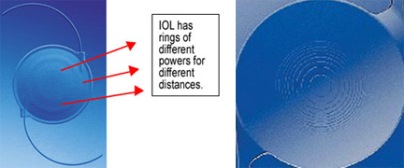
Figure 7. Some multifocal intraocular lens designs. Left – Advanced Medical Optics Array IOL with different annular refractive zones. Right – Alcon ReStor multifocal IOL with refractive and diffractive annular zones. Images from http://www.eyesurgerycenterla.com/emerging_tech.htm, and http://www.revoptom.com/index.asp?page=2_1533.htm.

There are other investigational intraocular lenses that incorporate elements such as flexible haptics that allow the ciliary muscle to change the position of the artificial lens. Corneal surgery creating an add power out of the patient’s own corneal tissue, or from inserting an intracorneal lens for near viewing are also being explored. However, all of these options are considered experimental at this time.
With the advent of LASIK and other refractive surgeries, it is important to explain to patients who have a distance vision correction that the need for near correction will still occur as they get older. Refractive surgery does not mean that near vision will be clear for a lifetime. True surgical correction of presbyopia has not yet been perfected.

Age-Related Changes in Spherical Ametropia
Due to a gradual decrease in the power of the crystalline lens, emmetropic or hyperopic eyes tend to change in the hyperopic direction. This is called age-related hyperopia. Others (particularly those eyes with low myopia) may change toward emmetropia. In myopic eyes, the decrease in lens power may be counteracted by a continued increase in axial length, with the result that some myopic eyes become more myopic after age 45 or 50, some change very little.
There is also a tendency for some eyes - whether hyperopic, emmetropic, or myopic - to change in the myopic direction due to the development of nuclear cataracts.
As a result of a review of patient records in his optometric practice in Ojai, California, Monroe Hirsch (5) reported age-related changes in refraction of patients beyond the age of 45. He found a definite hyperopic trend in hyperopes and emmetropes, but not in myopes. Prevalences of hyperopia, emmetropia, and myopia at ages 45 to 49 years and ages 75 and over were:
- Hyperopia (+1.13 D or more): 16% at age 45 to 49, and 48% at age 75 and over.
- Emmetropia (+1.12 to -1.12 D): 77% at age 45 to 49, and 37% at age 75 and over.
- Myopia (-1.13 D or more): 7% at age 45 to 49, and 15% at age 75 and over.
In a retrospective longitudinal study that Peter Skeates and I conducted using data on patients he had examined in his optometric practice in a suburb of Auckland, New Zealand, we reported changes in refraction per decade for 100 patients who were hyperopic, 100 patients who were emmetropic, and 100 patients who were myopic at the age of 40 years (6).
Of 100 patients who were hyperopic (+1.00 D or more) at age 40:
- 62 patients per decade became more hyperopic;
- 36 patients per decade changed less than 0.50 D per decade; and
- 2 patients per decade shifted toward myopia.
Of 100 patients who were emmetropic (+0.87 D to -0.37 D) at age 40:
- 54 patients per decade became hyperopic;
- 43 patients per decade remained emmetropic; and
- 3 patients per decade became myopic.
Of 100 patients who were myopic (-0.50 D or more) at age 40:
- 19 patients per decade became less myopic;
- 66 patients per decade changed less than 0.50 D per decade; and
- 15 patients per decade became more myopic.
We concluded that when a hyperopic shift occurred, it was due to an increase in the index of refraction of the lens; but when a myopic shift occurred, it was most likely due to incipient (pre-clinical) cataracts. But for a myopic eye, a likely cause of a myopic shift was continued axial elongation.

Age-Related Changes in Astigmatism
Keratometric data routinely show that beyond the age of 40 to 45 years, there is a strong tendency for astigmatism to change in the against-the-rule direction. It has been suggested that when with-the-rule astigmatism is present, it is because the stiff upper tarsal plate causes pressure on the horizontal meridian of the cornea. With increasing age, this pressure gradually decreases, resulting in a change toward against-the-rule astigmatism. This common observation has been confirmed in studies reported by Hirsch (7), Lyle (8), and other investigators.
In the retrospective study of patients examined by Peter Skeates in New Zealand, we found that age-related changes in astigmatism tended to differ for myopic eyes as compared to hyperopic and emmetropic eyes:
- Myopic eyes had a significantly greater prevalence of with-the-rule astigmatism at the first examination after age 40;
- Myopic eyes also had a significantly greater prevalence of changes toward against-the-rule astigmatism in the years following age 40 than hyperopic or emmetropic eyes (9).

Age-Related Changes in Retinal Illumination
In the last chapter of his book, Weale discussed age-related changes in what we would now call retinal illumination. (1) Referring to the results of a study he had published two years earlier, he commented:
"It can be shown that, as a result of miosis and lenticular yellowing, the 60-year-old retina receives approximately one-third of the amount of light which reaches the 20-year-old retina. It does not matter very much whether the eye is light or dark- adapted."

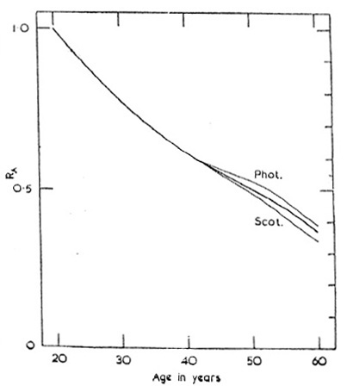
Figure 8. The relative amounts of light reaching the light-adapted (photopic) or dark-adapted (scotopic) retina at various ages between 20 and 60 years. Weale (1)

Weale’s study on retinal illumination (1) apparently didn’t include subjects who had undergone cataract surgery: anyone who has had the current ‘no-stitch’ lens extraction by phacoemulsification - followed by intraocular lens implantation - has found that everything appears to be much brighter, particularly in the violet and blue end of the spectrum. However, prior to the decade of the 1980s, patients were usually not referred for lens extraction until the cataract was ‘ripe’ - which would seldom occur before age 60.

Age-Related Changes in Visual Acuity and Contrast Sensitivity
Although the majority of people retain good high-contrast visual acuity into their sixties or seventies, low-contrast visual acuity and acuity in the presence of glare tend to show deficits at much earlier ages.
How Do We Define Contrast?
Contrast may be defined as the ratio of the difference between the maximum and minimum luminance (L) of a test stimulus, divided by the sum of the maximum and minimum luminance. To express contrast in terms of percentage, the result is multiplied by 100.
Percentage contrast = 100 [L(max) - L(min)] / [L (max) + L(min)]
For black print (the minimum luminance) on a white background (the maximum luminance), the contrast would be close to 100 percent; but for visual tasks such as viewing an airplane in a cloudy sky or recognizing a human face, the contrast may be close to zero.
High-Contrast Visual Acuity
The experience of vision care practitioners is that until about age 65, very close to 100 percent of their patients can achieve 20/20 to 20/30 (6/6 to 6/9) visual acuity in one or both eyes with conventional glasses or contact lenses. This clinical experience has been reinforced by a study reported by Klein, et al., (10) involving 4,926 residents of Beaver Dam, Wisconsin between the ages of 43 and 86 years. All subjects who volunteered for the study were included regardless of any signs of ocular disease.
Klein, et al., reported that more than 99% of their subjects between ages 46 and 64 years had corrected visual acuity of 20/20 (6/6), reducing to 95% for patients between ages 65 and 74, and 77% between ages 75 and 86 years.

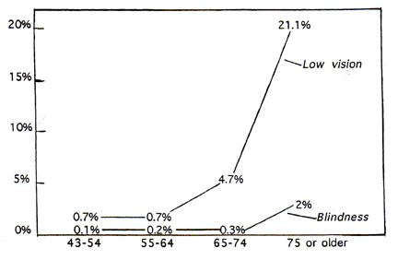
Figure 9. Percentages of subjects with low vision (20/40 to 20/160) (6/12 to 6/48), or blindness (20/200 [6/60] or worse), reported in the Beaver Dam Study (10).

Less than 1% of the subjects had visual acuity of 20/40 to 20/160 (6/12 to 6/48) (low vision) between ages 46 and 55 years, increasing to 21% at age 75 or older; while only 2% were ‘legally blind’ at age 75 and older.
Low-Contrast Visual Acuity
A growing body of research demonstrates that macular degeneration, cataracts, and other age-related ocular diseases can cause significant losses in contrast sensitivity for certain spatial frequencies. Sekular, et al., (11) compared contrast sensitivity for 70 subjects in their 60s, 70s, and 80s who were free of ocular disease, and 33 subjects in their 20s and 30s, also free of ocular disease. Their results indicated that although subjects of all ages had equal sensitivity for the lowest spatial frequencies (0.5 and 1.0 cycles per degree), there was a decrease in sensitivity for the higher spatial frequencies for each decade of life.

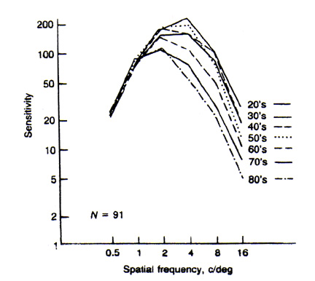
Figure 10. Age-related changes in contrast sensitivity. Sekular, et al. (11).

Noting that the average retinal illuminance of the 60 year-old eye was estimated by Weale (1) as only about one third of that of the 20 year-old eye - due to the smaller pupil and increased density of the lens – Owsley, et al., (12) tested contrast sensitivity on a group of 20 year-old subjects who wore a neutral density filter that decreased contrast sensitivity by a factor of 3. As shown in Figure 11, contrast sensitivity for these subjects through the filter was found to decrease for higher spatial frequencies, but not to the extent of the decrease found for older subjects.

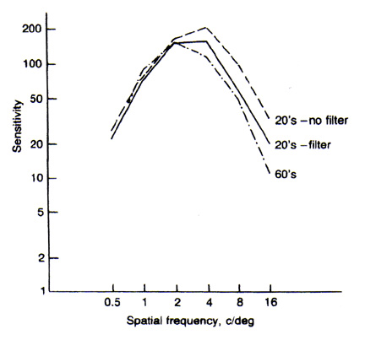
Figure 11. Change in contrast for twenty-year-old subjects wearing a neutral density filter, compared with subjects in their 60s not wearing a filter. Owsley, et al. (12).

Owsley, et al., concluded that the decrease in the light reaching the retina for three older subjects, as found by Weale, might have been due to additional neural rather than optical factors.

Testing Contrast Sensitivity
In contrast sensitivity testing, the patient is presented with repetitive stimuli in the form of vertically-oriented gratings at various contrast levels. They may be square-wave gratings or sine-wave gratings. The gratings are designed so that the average luminance - half the sum of the luminance of the dark and light bars - is constant for all gratings.
The spacing between the outer edges of any two bars in a grating is the spatial frequency, which is analogous to the width of a stroke and a gap on a visual acuity chart. For example, a spatial frequency of 30 cycles per degree (30 bars and 30 gaps per degree) would indicate a stroke or gap width of one minute of arc, and would therefore be the equivalent of 20/20 (6/6) visual acuity. The first contrast sensitivity tests to be developed, which were used mainly for research, consisted of electronically-generated gratings.
The Arden Plate test.
Introduced in 1978 by C.S. Arden (13), it was one of the first contrast sensitivity tests designed for clinical use. The test is in the form of a 6-page booklet, with each page (Figure 12) displaying several sine-wave gratings of varying contrast and spatial frequency. Each grating is oriented vertically, with the contrast varying from the top to the bottom. For each grating, the examiner or the patient gradually moves a card (which masks the grating) downward over the page until the point is reached at which the grating is seen.
At that point, the examiner records the contrast from a scale provided with the grating. After a practice trial, the procedure is repeated for each of the six plates.

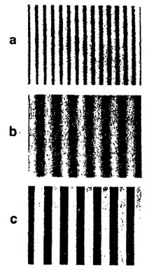
Figure 12. The Arden Plate test. Gratings (a) and (b) differ in spatial frequency, and gratings (b) and (c) differ in contrast. Arden (13).

The Vistech chart.
Developed in 1984 by Ginsberg (14), the Vistech chart is made up of 6 rows of 3-inch diameter sine wave gratings. Each row consists of a sample grating and various test gratings at a given spatial frequency but differing in contrast. Spatial frequencies utilized - from the top row to the bottom row - are 1, 2, 4, 8, and 16 cycles per degree. Each grating is oriented in one of 3 directions: vertical, slanted 15 degrees to the left, or slanted 15 degrees to the right.
The task of the patient is to report the orientation of each grating in each row until the orientation cannot be determined. When the test is completed, the data are plotted and compared to a ‘normal’ contrast sensitivity curve. Two separate Vistech charts are available: the VCTS- 6500 for distance testing, and the VCTS-6000 for near testing. A projector slide, the VCTS-500S, has also been available.

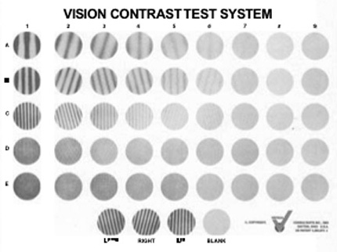
Figure 13. The Vistech contrast sensitivity test. Ginsberg (14).

The Melbourne Edge Test.
Developed by Verbaken and Johnson (15) in 1986, this test was based on the idea that contrast sensitivity for a single edge appears to be a reliable indicator of the contrast sensitivity function peak. The test makes use of the boundary between light and dark backgrounds, rather than a grating.
Shown in Figure 14, the test is made up of 20 circular stimuli, 2.5 cm (1 inch) in diameter. Each of the circles, or disks, presents an edge that separates light and dark backgrounds with gradually reducing contrast. The identifying feature is the orientation of the edge. The patient is shown a key card that presents four circles, having horizontal, vertical, and obliquely oriented dividing lines; and the patient is asked to identify the orientation of each of the test edges.

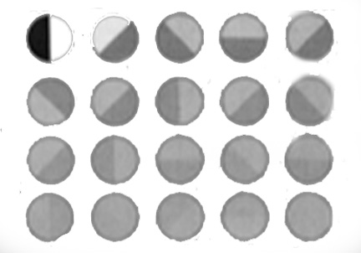
Figure 14. The Melbourne Edge Test. Verbaken and Johnston (15).

In one study, the Melbourne Edge Test was administered to 497 consecutive clinical patients. Patients were split into 3 groups on the basis of visual acuity and media haze. It was concluded that edge contrast sensitivity provided diagnostic data that were not available from visual acuity testing alone (15).
Variable-Contrast Letter Charts
The possibility that some older patients, whose visual acuity as tested in the eye doctor’s office was 20/20 (6/6), might have difficulty in some ‘real world’ situations, was understood as long ago as the 1950s, when at least one ‘low contrast’ visual acuity chart was developed. But the majority of clinicians failed to understand the need for low-contrast acuity testing until widespread contrast sensitivity testing was done in several research laboratories. Once the ‘low contrast acuity’ problem gained acceptance, variable-contrast letter charts began to appear in the clinical setting.
The Mentor B-VAT II.
This instrument was one of the first low-contrast visual acuity tests to make use of the familiar Snellen letters. This test is described by the manufacturer as a high-contrast, high-resolution monitor providing nine different optotypes and over 50 functions with a built-in red-green test for refining refractions. Stimuli are presented randomly to prevent memorization.
The B-VAT II SG
(Figure 15) is designed not only for routine vision testing, but it also presents sinusoidal gratings at various levels of contrast and spatial frequencies. The test can be set at either 3 or 6 m (10 or 20 ft) and uses 20 contrast steps. For each presentation, an auditory tone is used to alert the patient. Gratings may be oriented vertically or 14 degrees clockwise or counterclockwise from vertical.

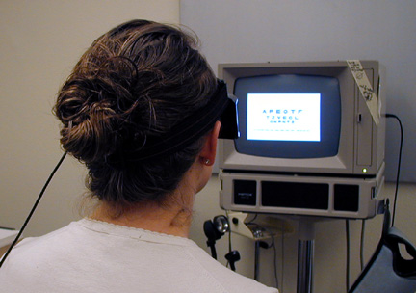
Figure 15. Mentor B-VAT II SG Video Acuity Tester.

In a study using 69 optometry students as subjects, Corwin, et al., (16) concluded that the B-VAT II SG system provides reliable contrast sensitivity data, which are consistent with norms from other systems when obtained under similar conditions.
The Peli-Robson Letter Chart.
In this chart, all letters are the same size, but contrast decreases from the top to the bottom. As described by Peli, et al., (17), the test is in the form of a printed cardboard chart, which presents 8 lines of letters consisting of 6 letters each. All of the letters subtend an angle of 0.5 degrees at a testing distance of 3 meters.

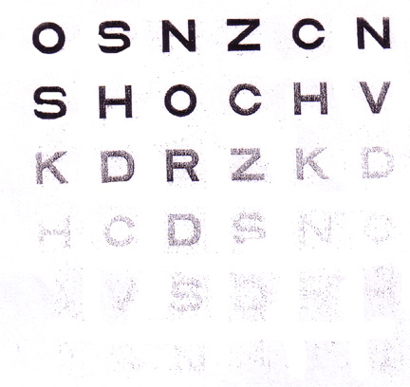
Figure 16. The Peli-Robson Letter Chart.

Because each Snellen letter consists of 3 strokes and 2 gaps (2.5 cycles) the spatial frequency of each letter is 1.25 cycles per degree; this is equivalent of 6/36 (20/120) visual acuity.
As for contrast, each line consists of 3 letters, all letters in a group having the same contrast. The contrast is highest for the first 3 letters on the top row, and lowest for the last 3 letters on the bottom row, decreasing for each successive group of 3 letters. The patient’s score is determined by the last group in which 2 of the 3 letters are read correctly.
Regan Low-contrast Letter Charts.
This test consists of 3 letter charts, having contrasts of 94%, 7%, and 3%. They are used at a distance of 3 m, and are designed on the Bailey-Lovie principle, with the exception that there are 8 letters, rather than 5, in each line. When using these charts, patients are instructed to start reading at the top and to continue reading until they can correctly identify none of the letters on a line. In most cases, only the 97% and 3% charts are used.
In discussing the use of these low-contrast charts, Regan (18) suggested that their chief role is in detecting early visual loss, especially in diabetes and glaucoma, in the hope of enabling timely management to prevent or delay further visual loss. He also discussed their role in the detection of Parkinson’s disease, central serous chorioretinopthy, and cataracts.

Disability Glare
Sources of illumination that present no problems for most people can sometimes cause devastating effects on vision for patients who have conditions such as corneal edema, lens opacities, various forms of maculopathy, and dry-eye problems. The first test for disability glare - the Miller-Nadler Glare tester - has been available for more than 30 years, but has seen very little use. More recently, however, several new tests of disability glare have been introduced, many of which are also intended for the measurement of low-contrast visual acuity.
The Mentor Brightness Acuity Tester (BAT).
This test is designed to convert a visual acuity test or a contrast sensitivity test to a test for disability glare. It is an illuminated white hemisphere, 60 mm in diameter with a 12 mm central aperture. It is held over the patient’s eye, as the patient views a visual acuity chart through the aperture. The internal brightness of the hemisphere can be varied, therefore varying the amount of glare. An important advantage of this instrument is that it can be used with any visual acuity chart, and with many variable-contrast acuity charts including the Peli-Robson test and the Regan charts.

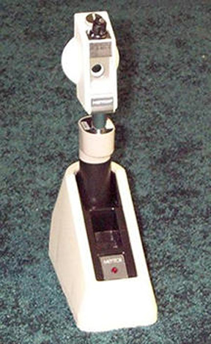
Figure 17. Mentor Brightness Acuity Tester (BAT).

The Berkeley Glare Test.
Developed by Bailey and Bullimore (19), this test is based on the Bailey-Lovie principle and takes the form of a single chart with a constant contrast of 10%.
As shown in Figure 18, the chart is in the form of a triangle and is surrounded by an opal Plexiglas background, which can serve as a glare source. When used without the glare source, the chart is front-illuminated, independent of the surrounding glare source.
When background illumination is desired, incandescent bulbs behind the Plexiglas screen can yield surround luminances of 30, 800, and 3,000 candelas per square meter. To determine the effects of glare on high-contrast visual acuity, the low-contrast chart can be replaced by the high-contrast Bailey-Lovie chart. The test is designed for use at a distance of 1 m. The eye being tested is corrected with the appropriate lens for this viewing distance (e.g., for an absolute presbyope this would be the distance correction with a +1.00 D add).
The method of specifying visual acuity is by means of a visual acuity reading (VAR) scale. This is a logarithmic scale that gives 5 points for each line of letters read (each line consists of 5 letters) and one point for each additional letter.
The Bailey-Lovie Acuity Chart shown in Figure 18, is a high-contrast visual acuity chart in which there is a size-progression ratio of 5 to 4 throughout the chart, i.e., the angular size of each row of letters is four-fifths that of the preceding row. Each row has the same number of letters; and a constant spacing is used between rows and between letters.
The chart is designed on a logarithmic basis, and visual acuity is designated in terms of the logarithm of the minimum angle of resolution (logMAR). For example, visual acuity of 6/60 (20/200) represents a minimum angle of resolution of 10 minutes of arc. Because the logarithm of 10 is 1, visual acuity of 6/60 (20/200) can be expressed as a logMAR of 1.0.

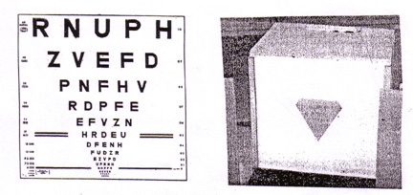
Figure 18. Left: The Bailey-Lovie acuity chart. Right: The Berkeley glare test.

It follows that an acuity of 6/6 (20/20), representing a minimum angle of resolution of 1 minute of arc, whose logarithm is 0.0, has a logMAR of 0.0. On the chart, there are 10 steps between 6/60 (20/200) or logMAR 1.0, and 6/6 (20/20) or logMAR 0.0. The chart is designed to be used at a distance of 6 m (20 ft), and if it is used at a shorter distance, a distance correction factor must be applied.
Contrast sensitivity and glare test results compared to patient symptoms
Visual acuity, contrast sensitivity, glare sensitivity, and other visual functions were compared for 50 older patients (68 to 87 years) and 20 middle-aged patients (40 to 60 years) by Rumsey (20). Visual acuity was tested monocularly at distance and near; monocular contrast sensitivity was tested with the Bailey-Lovie low contrast charts; and monocular glare sensitivity was assessed with the Mentor Brightness Acuity Tester at high, medium, and low illumination levels using at a 6 m viewing distance.
Mean values of distance visual acuity, contrast sensitivity, and glare sensitivity were all found to be significantly poorer for the older patients than for the middle-aged patients. Rumsey compared the results of the clinical tests to the complaints made by the patients in routine case histories, with the following results:
- A decline in vision was reported by 72% of the older group but by only 10 % of the middle-aged group.
- Complaints of diminished driving ability were reported by 45% of the older group, and by 25 % of the middle-aged group.
- Problems with glare were reported by 49% of the older group and by 30 % of the middle-aged group.
In discussing these results, Rumsey suggested that when taking case histories, using more specific, task-oriented questions might be more effective in identifying decrements in visual function.
Should we test low-contrast acuity and glare acuity on all older patients?
Many contrast sensitivity tests results bear no obvious relationship to those of conventional visual acuity charts based on Snellen letters. However, they serve an important purpose in enabling researchers and practitioners to evaluate vision in low-contrast situations. Several variable-contrast visual acuity tests are now available, in addition to tests for visual acuity measured in the presence of glare.

'Attentional' Visual Vield Loss
Hagerstrom-Portnoy, et al., (21) conducted a large battery of tests on 900 adults between the ages of 52 and 102 years who were recruited from the subject population of a broader study by the Buck Center for Research and Aging in Marin County, California. There were no exclusion criteria other than age; and visual acuity was measured while the subject wore his or her habitual correction, if any.
One of the tests conducted was the Smith-Kettelwell Attentional Field Test, making use of a perimeter equipped with a red LED (light-emitting diode) as a fixation point, with peripheral targets in the form of bright green LEDs. The visual field was first tested in the normal manner, after which the attentional field was tested. During the attentional field test, the experimenter briefly turned the red fixation LED off and on at predetermined intervals, and the subject was asked to silently count the number of times the light turned on and off. In the discussion of their results, the researchers commented:
"Whereas standard field extent changes very little with age, attentional field size decreases dramatically, accompanied by enormous increases in variability. Twenty-five percent of the oldest age group had no peripheral fields under conditions of divided attention."

Age-Related Changes in Ocular Health That Can Cuase Acuity and Contrast Sensitivity Reduction
Although many age-related changes in ocular health are vision-threatening, there are other, less serious problems that can cause blurring of vision and other symptoms.

Problems with the Lacrimal System
One of the most pervasive age-related vision problems has to do with the formation, distribution, and elimination of tears. As a result of contact lens popularity, vision care practitioners are much more aware of the problems of excessive tearing - epiphora - which can be due to any of several conditions, from an everted or blocked punctum to the wearing of rigid contact lenses; and too little tearing - dry-eye - due to any of several conditions varying from Sjogren’s syndrome to a badly-fitting contact lens or a reaction to any of several medications.
Dry-eye syndrome can occur due to insufficient aqueous secretion, as confirmed by the Schirmer tear test in which there is less than 10 mm of wetting of the filter paper during a 5-minute period; or to a deficiency of the mucin layer, as confirmed by tear beak-up time of 10 seconds or less. The phenol red thread test (Menicon) can also assess aqueous secretion in a 30 second test similar to the Schirmer test. Both of these tests can be performed either with or without topical ophthalmic anesthetic. Performing the tests with anesthetic provides a basal tear secretion evaluation, negating the effects of reflex tearing (a physiological response from the filter paper or thread contacting the eye).
Recent theories on the etiology of dry eye syndrome include a complex inflammatory-neural feedback loop between the lacrimal gland, external ocular tissues and neural release of inflammatory mediators. Current treatment is often directed towards breaking this cycle by blocking the inflammatory component to dry eye disease.
Keratoconjunctivitis sicca is a dry-eye condition that has been described by Lemp (22) as predominately a disorder of menopausal and postmenopausal women. In the Dictionary of Visual Science and Related Terms, Hofstetter, et al., (23) gave the following definition of keratoconjunctivitis sicca:
"Keratoconjunctivitis characterized by insufficient lacrimal secretion, keratinization of the superficial epithelial cells, signs of chronic catarrhal conjuctivitis with dry mucoid secretion, and punctate or linear opacities in the cornea…."
Sjogren’s syndrome has been described by Lemp as consisting of a triad of dry eyes, dry mouth, and arthritis. It has been defined by Hofstetter, et al., as:
"Failure of lacrimal secretion…failure of secretion of the salivary glands and the mucous glands of the upper respiratory tract, and polyarthritis, usually occurring in women after menopause, due to degeneration of the glandular parenchyma followed by fibrosis, of undetermined causation."
Prevalence of Dry-Eye in an Adult Population
As a part of the Beaver Dam study, Moss, et al., reported the results of a 5-year longitudinal analysis of dry-eye data of 2,414 subjects between the ages of 43 and 84 years. (24) They found that during the 5-year interval, dry-eye developed in 13% of the subjects. The incidence of dry-eye was found to be significantly associated with age (P less than 0.001). Age-adjusted incidence of dry-eye was found to be:
- Greater in subjects with a history of allergy,
- Greater in subjects with a history of diabetes,
- Greater in subjects who used antihistamines or diuretics,
- Greater in subjects with poorer self-reported health,
- Lower in subjects using ACE-inhibitors (for systemic hypertension), and
- Lower in subjects consuming alcohol.
Management of Dry-Eye
In the textbook Ophthalmology, Principles and Concepts, Newell (25) made the following comments:
"The treatment of dry eyes is often unsatisfactory. Artificial tears are commercially available, and patients often experiment until they find one that provides relief. Frequent instillation may be required…Obstruction of the inferior and superior puncta to conserve tears cannot be effective if no tears are present…."
During the 3 decades since Newell made these comments, management of dry-eye syndrome continues to be a problem. My experience has been that after a trial period with some of the newer (and very expensive) tear products, many people settle for the occasional use of a single-dose unpreserved saline artificial tear. Recently, more viscous and lubricious forms of artificial tears (e.g., Refresh Liquigel® by Allergan, TheraTears Liquid Gel® by Advanced Vision Research, and Systane® by Alcon) are providing treatment alternatives. Various types of punctal plugs (surface and intracanalicular), as well as punctal cautery are other options. One of the more unique treatments is the use of topical cyclosporine drops (Restasis® by Allergan) twice a day, long-term. The topical cyclosporine antimetabolite drug is thought to block the dry eye ‘inflammatory loop’ resulting in reduction of dry eye signs and symptoms.
How about prevention? It is becoming increasingly obvious that prevention is the key to solving many age-related dry-eye problems
The Role of Fatty Acids in Dry-Eye Problems
In recent years, the role of fatty acids in inflammation - and therefore in dry-eye problems involving inflammation - has received increasing attention. In a discussion of essential fatty acids in Contact Lens Spectrum, Nichols (26) said that because the body doesn’t produce the essential fatty acids, they must be obtained from food; and that both omega-3 and omega-6 fatty acids play an important role in nutrition.
Researchers have found that whereas the desirable ratio of omega-6 to omega-3 fatty acids is 4 to 1 or 5 to 1, the average ratio in the typical American diet is a much higher 12 to 1. In a table comparing omega-3 and omega-6 fatty acids, Nichols provided the following information:
"Omega-3 fatty acids are present in flax, flax oil, canola oil, walnuts, leafy-green vegetables, and cold-water fish. Omega-6 fatty acids are present in vegetable oils (corn, sunflower, safflower), meat (grain-fed livestock), cereals, grains, and margarine."
Should we be concerned about mercury in fish?
An article in the American Heart Association’s Website with the title "Fish, Levels of Mercury, and Omega-3 Fatty Acids" (27) began with this advice:
"Fish is a good source of protein and, unlike fatty meat products, it’s not high in saturated fat. It’s also a good source of omega-3 fatty acids, which benefit heart health. The American Heart Association recommends eating fish at least twice a week. However, some types of fish may contain high levels of mercury, PCBs (polychlorinated biphenyls), toxins, and other environmental contaminants."
This was followed by a table, listing the top ten fish and shellfish consumed in the United States, together with their levels of omega-3 fatty acid (in grams per 3-ounce serving) and mercury (in parts per million). The mercury levels ranged from highs of 0.12 to 0.11 parts per million for tuna and cod, to a low of 0.01 for salmon.
The omega-3 fatty-acid contents (in parts per million) of various fish and shellfish, from highest to lowest, were listed as:
- Salmon (fresh/frozen): 0.68 to 1.83
- Pollock: 0.46
- Flounder or sole: 0.43
- Crabs: 0.30 to 0.40
- Canned tuna (light): 0.28 to 0.72
- Shrimp: 0.27
- Clams: 0.24
- Scallop: 0.17
- Catfish: 0.15 to 0.20
- Cod: 0.13 to 0.24
Other Nutritional Roles Played by Fatty Acids
It is important to understand that the prevention of dry-eye problems is not the only role played by the essential fatty acids. As outlined on the American Heart Association’s Website, essential fatty acids are involved in the maintenance of cardiovascular health, including:
- A decreased risk of arrhythmias, which can lead to sudden cardiac death,
- A decrease in triglyceride levels,
- A decreased growth rate of atherosclerotic plaques, and
- A slight decrease in blood pressure.
In an article on the subject of nutrition and dry eye, published in Optometric Management, Thimons (28) said:
"Studies indicate that, in addition to promoting eye health, omega-3 fatty acids play a role in the regulation of blood clotting and vessel constriction, as well as depression and irritable bowel syndrome. They are also important in pre-and post-natal development and alleviate the symptoms of rheumatoid arthritis."

Cataracts
Although not typically considered "eye threatening" in the United States and other developed countries, cataracts can produce significant reductions in retinal illumination, acuity, and contrast sensitivity. (For purposes of this course, age-related cataracts are considered to be an opacification that interferes with visual acuity, and not an eye disease.)
When I opened an Optometric office during the post-World War II years in the small town of Franklin, in southwestern Ohio, many young people had left for bigger cities to find employment, so my patient population seemed to have an excess of older folks. I soon found the most common age-related vision problems to be what were then known as senile macular degeneration and senile cataracts.
At that time there was no medical or surgical treatment for macular degeneration: patients were told that they might eventually lose their ability to read or drive an automobile, but they would always retain some ‘side vision.’ During the 1950s, low vision care was in its infancy; and optometrists began to occasionally prescribe bifocal additions stronger than +2.50 D.
As for cataracts, the intracapsular method of surgical extraction was not usually done until the vision in the better eye was 20/50 or worse, so patients had to endure several years of blurry vision. Until corneal contact lenses were introduced in the 1950s, post-cataract patients had to wear thick, high-plus spectacle lenses with their high magnification, reduced visual field, and other problems.
During the several years prior to surgery, patients who had nuclear cataracts would gradually become myopic. It was not uncommon for a +2.00 D hyperope to gradually become a -2.00 D myope before surgery was done, and to be able to read without glasses: thus the term ‘second sight.’
There was a time when cataracts caused as much vision impairment and blindness as macular degeneration - if not more. Even today, cataracts are a major cause of blindness in regions of the world where modern methods of cataract extraction are not available. In an article with the title “Modern Surgery for Global Cataract Blindness,” Gillies, et al., (29) said:
"Unoperated cataract in the developing world remains ophthalmology’s major unsolved problem."
At the turn of the current century, cataracts were still the second or third most frequent cause of vision impairment and blindness - but with the gradual increase in the prevalence of diabetic retinopathy, cataracts are currently the third or fourth greatest cause of vision impairment in the United States, Canada, and many other countries.
Like glaucoma, cataracts occasionally occur in children and young adults, and as a result of other conditions, but in the great majority of cases they occur during the later adult years, as age-related cataracts.
How Many People Have Cataracts?
In one of the many reports concerning the Beaver Dam Eye Study, Mares-Pullman, et al., (30) presented data concerning the 5-year incidence of cataracts, based on data collected on persons aged 43 to 78 years old.
A baseline examination was done between 1988 and 1990 (4,926 subjects), and a follow-up examination was done between 1993 and 1995 (3,685 subjects). The incidence of cataracts during the 5-year period was:
- Nuclear cataract, 13.1% of right eyes,
- Cortical cataract, 8.0% of right eyes, and
- Posterior subcapsular cataract, 3.4% of right eyes,
- For a total of 24.5% of right eyes.
The American Foundation for the Blind (31) has reported that approximately 50% of Americans age 65 to 74 years and 70% of Americans over age 75 have cataracts, and has suggested the following "Ways to Help Individuals with Cataracts":
- Use bright primary colors with high contrast,
- Provide reading materials that have high contrast, such as large black print on white or light yellow paper, a minimum of 18 point,
- If printing, use black felt-tip pens on white paper for highest contrast,
- Adjust window shades to reduce direct sunlight, and
- Wear sunglasses and a hat when outdoors on sunny days.
Detection and Diagnosis of Cataracts
Age-related cataracts - unlike macular degeneration, diabetic retinopathy, and glaucoma - can be detected by a procedure no more complicated than shining a small flashlight into the eye at an oblique angle. This is one reason why surgical teams have been able to travel through tropical and sub-tropical regions, including India and Nepal, detecting cataracts with minimal diagnostic equipment and performing lens extraction followed by IOL placement.
A complete diagnostic procedure requires visual acuity measurement, examination with the biomicroscope and ophthalmoscope under dilation, visual field evaluation, and other procedures conducted in a comprehensive eye and vision examination. Age-related cataracts can occur in any - or a combination of - three types.
Nuclear cataract is an opacification of the nucleus, or central portion of the lens (Figure 19). With increasing age, the nucleus gradually takes on a yellowish or brownish color - a brunescent cataract. The presence of a nuclear cataract not only causes an increase in the index of refraction of the lens, causing the refractive state to change as much as 4 or 5 D in the myopic direction, but it gradually reduces the brilliance of light in the violet and blue portion of the spectrum. Most people are not aware of this gradual change until after cataract extraction, when they find that violet and blue colors are much more brilliant!
Cortical cataract, as the name implies, is an opacification of the outer cortex of the lens. It typically begins with spoke-like opacities in the lens periphery, which can be seen by a penlight, a biomicroscope or an ophthalmoscope only if the pupil has been dilated, as shown in Figure 19. In the early stages, a cortical cataract causes relatively little interference with vision, but it will eventually extend into the central portion of the lens and caused blurred vision - especially in low contrast situations and in the presence of glare.
Posterior subcapsular cataract typically begins as a small, black ‘spot’ at the back of the lens (Figure 19) just inside the lens capsule when viewed with light retroilluminated off the fundus. Being located in the axial portion of the lens, it tends to interfere with vision in the very earliest stages, especially in bright light when the pupil is small.

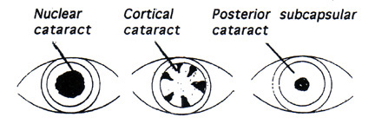
Figure 19. Age-related cataracts.

Management of Cataracts
Although several methods of cataract management have been suggested - including questionable methods such as ‘light therapy’ in which the patient is advised to sleep in a lighted room so that the pupil will not dilate during sleep, or the use of solvents to ‘dissolve’ a cataract - surgical removal of the cataractous lens is currently the only successful method of managing a cataract.
When should the patient be referred for surgery?
For many years, the extraction of a cataractous lens could not be done until the cataract was ‘ripe,’ which would occur when the lens had become sufficiently rigid so that it could be removed intact out of the eye with an instrument having the structure and function of a small spoon.
Usually, by the time the cataract was sufficiently ‘ripe’ for surgery, visual acuity would have deteriorated to 20/40, 20/60 (6/12, 6/18), or worse, which meant that there was a period of several months or even years when reading and other visual tasks were all but impossible. Over the years, as surgical procedures improved, the waiting period for surgery decreased somewhat.
A much more serious problem with cataract surgery was the possibility of a fatal outcome due to the oculocardiac reflex (32). The pressure on the ocular tissues during surgery could stimulate the vagal nerve, causing a cessation of breathing. During the years that I practiced optometry in Franklin, Ohio, some patients refused to have cataract surgery because a resident of the community had failed to survive the procedure several years earlier.
In addition to the possibility of not surviving surgery, there was the problem of having to tolerate the high magnification and aberrations caused by post-surgical high plus spectacle lenses. Because of these aberrations, the patient would often experience what is known as the jack-in-the-box phenomenon; objects in the periphery would suddenly come into view and disappear as eye or head movements were made.
Another problem was that temporary lenses would have to be worn for some weeks or months after the surgery, before the final ‘aphakic lenses’ could be prescribed.
Important breakthroughs were the development of rigid contact lenses, followed by soft contact lenses, both of which reduced the magnification and almost completely eliminated the aberrations. Because many patients found it difficult to remove the contact lenses at night and put them back on in the morning, continuous-wear soft contact lenses were introduced, which were soon followed by disposable and frequent-replacement lenses. The next step was the development of intraocular lenses, making spectacle lenses or contact lenses for distance vision unnecessary.
Lens Extraction by Phacoemulsification
The most recent advance has been the ‘no-stitch’ phacoemulsification procedure: A tiny incision is made at the upper limbus and the lens material is broken up by means of an ultrasound probe and is removed from the eye, after which a ‘foldable’ plastic intraocular lens (IOL) is inserted into the lens capsule, through the tiny incision. Prior to the surgery, the axial length of the eye is measured, and a computer program is used to determine the required IOL power.
Several years ago my wife and I both experienced bilateral lens extraction by the phacoemulsification procedure. For both of us, it was a pleasant and painless experience, involving only a local anesthetic; and resulting in clear vision immediately after the surgery. Having been amblyopic in my right eye, and having recently had a retinal detachment (and surgical repair) in the left eye, my visual acuity prior to the cataract extraction was no better than 20/50 (6/15) in each eye, with much poorer acuity in low-contrast situations and in the presence of glare.
After the surgery my visual acuity had not only improved to 20/40 (6/12) on the high-contrast acuity chart, but my vision in low-contrast and glare situations had greatly improved, including increased brilliance of colors in the violet and blue range. An unexpected advantage was an improvement in my near visual acuity while wearing absorptive lenses intended for distance vision; while wearing these lenses, I could pick up a letter at the local post office and read the name and address on the envelope! (However, my progressive-addition lenses are necessary for any serious reading.) I concluded that this improvement in near vision is due to the optical quality of the IOLs, as compared to that of my gradually yellowing crystalline lenses.
Although it is hypothesized that presbyopia is caused by a gradual loss of flexibility of the eye’s lens - so that it can no longer respond to the contraction of the ciliary muscle - there’s no doubt that a loss of depth of focus, due to a gradual reduction in the optical quality of the lens, is a part of the clinical picture: When near visual acuity gradually deteriorates during presbyopic years, the reduced acuity is partially due to a loss of transparency of the lens.
Complications of Phacoemulsification Surgery
Retinal detachment. Although lens extraction with replacement by an IOL is an extremely safe procedure, complications do occasionally occur. Retinal detachment is a possible complication of any form of cataract extraction, and can occur in any eye, but is much more likely to occur in a highly myopic eye. Before undergoing any form of lens extraction, a high-risk myopic patient may wish to seek the advice of a retinal surgeon.
When I was advised by a colleague at the Indiana University Optometry Clinic that I should have cataract surgery, I contacted the retinal surgeon who had recently repaired the retinal detachment in my left eye.
His advice was that neither of my eyes was at risk for a retinal detachment, and that there is never a reason not to remove a cataractous lens. If age-related macular degeneration should occur, the presence of a cataract would make it much more difficult for the retinal surgeon to evaluate macular degeneration, and to perform photodynamic therapy.
Opacification of the posterior capsule is a much more common, but also much less serious, complication of lens extraction by phacoemulsification. My experience is that it tends to occur during the first or second year after the surgery, and causes only a slight blurring of vision. It is treated by the creation of a tiny opening in the posterior capsule by means of a YAG laser - a YAG laser capsulotomy - an office procedure that takes only a few minutes.
My wife and I both noticed a slight blurring of vision in one eye several months after the lens extraction surgery, and eventually underwent the YAG laser procedure. In my case, a small change in the cylinder axis and power of the correcting lens was required.
Should IOLs block ultra-violet, violet, and blue radiation? Because blue light has been identified as a possible contributor to age-related macular degeneration, Braunstein and Sparrow (33) made the suggestion:
"Offering a blue light filtering intraocular lens (IOL) to patients undergoing cataract surgery is a significant advance in the quality of patient care."
Making the argument that ultra-violet radiation (330 to 400 nm) is potentially harmful to the retina, and violet light has substantial potential retinal toxicity but little effect on scotopic or photopic vision, Mainster (34) suggested that intraocular lenses should block ultra-violet radiation and short-wavelength violet light, but they should not block longer wavelength blue light.
Perhaps a simpler solution to this problem would be to wear photochromic spectacle lenses for general wear, with absorptive lenses - sunglasses - when outdoors on sunny days: for example, the large plastic sunglasses shown prior in Figure 20.

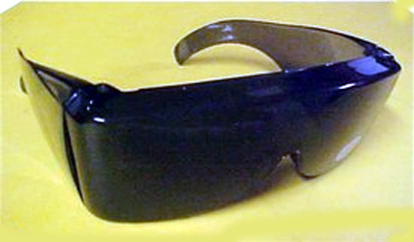
Figure 20. Protective sunglasses with wraparound side shields.

Can Cataracts be Prevented?
The risk factors for age-related cataracts are very similar to those for age-related macular degeneration:
- Age,
- Genetic susceptibility,
- Light-colored irides (blue eyes),
- Exposure to radiation from the sun,
- Cigarette smoking, and
- A lack of dietary antioxidants.
As with age-related macular degeneration, nothing can be done about age, genetic susceptibility, or eye color, but it is possible to limit exposure to sunlight, avoid cigarette smoking, and make sure that one’s diet contains sufficient antioxidants.
Radiation from the sun.
In an epidemiological study of 838 Chesapeake Bay watermen, Taylor, et al., (35) found that the cumulative exposure to ultraviolet radiation during a period of many years increased the risk of age-related cataracts. Cumulative exposure was calculated on the basis of UVB radiation for each subject during each year since age 15 years. At the time the data were collected, the mean age of the subjects was 53.0 years. Of the 939 subjects, 52% were found to have nuclear, cortical, or posterior subcapsular cataracts.
Because age-related cataracts seldom occur before age 50 years, the 52% prevalence for people whose average age is 53 years is much higher than would be expected. Taylor, et al., emphasized the importance of exposure to ultraviolet radiation during the earlier adult years. On the basis of these results, they suggested:
"A hat with a brim and close-fitting sunglasses with ultra-violet absorbing lenses should be worn at times of maximum exposure to sunlight."
An association between short-wavelength radiation and cataracts was also found in the Blue Mountains Study in Australia (Cumming, et al., 36).
Dietary antioxidants.
The Age-Related Eye Disease Study (AREDS) group (37) evaluated the effects of antioxidant supplements on the development of age-related cataracts. Finding no positive effect, they concluded:
"Use of a high-dosage formulation of Vitamin C, Vitamin E and beta carotene in a relatively well-nourished older adult cohort had no apparent effect on the 7-year risk of development or progression of age-related lens opacities or visual acuity loss."
In a publication of the on-going Beaver Dam study, Mares-Perlman, et al., (30) reported the results of a study designed to determine the relationship between vitamin supplement use and the 5-year incidence of nuclear, cortical, and posterior subcapsular cataracts.
Participants in the study were 3,089 residents of Beaver Dam, Wisconsin, ages 43 to 86 years. Data regarding the type, dosage, and duration of supplement use were obtained by interviews at follow-up. The following results were reported:
"Compared to nonusers, the 5-year risk for any cataract was 60% lower among persons who, at follow-up, reported the use of multivitamins or any supplement containing vitamin C or E for more than 10 years. Taking multivitamins for this duration lowered the risk for nuclear and cortical cataracts but not for posterior subcapsular cataracts."

Conclusion
Today, the older members of the ‘boomer generation’ are approaching age 60 and are looking forward to retirement. Hagerstrom-Portnoy, et al., (21) in 1999 quoted the U.S. Census Bureau as stating that by the year 2030 the over 65 population will more than double, to 75 million. With proper care and guidance, many of these patients can lead productive and happy lives with good vision. Others can be helped by lenses or procedures carefully chosen to maximize the vision that remains available to them.
This course has reviewed prevention, treatment, and remediation of the most common vision-threatening conditions experienced by the elderly, in the hope that this information will help to make ”the golden years” enjoyable for as many patients as possible.

References
- Weale R. The Aging Eye. London: Lewis, 1963.
- Borish IM, Hitzeman SA, and Brookman KE. Double-masked study of progressive addition lenses. J Amer Optom Assoc 51: 933-943, 1980.
- Horgen H, Aaras A and Thorenson M. Will visual discomfort among visual display unit (VDU) change in development when moving from single-vision lenses to specially designed VDU progressive lenses? Optom Vis Science 81: 341-349, 2004.
- Sheedy JE and Hardy RF. The optics of occupational progressive lenses. Optometry 76: 432-441, 2005.
- Hirsch MJ. Changes in refractive state after the age of 45. Amer J Optom 35: 229-237, 1958.
- Grosvenor T and Skeates PD. Is there a hyperopic shift in myopic eyes during the presbyopic years? Clin Exper Optom 82: 236-243, 1999.
- Hirsch MJ. Changes in astigmatism after the age of 40. Amer J Optom 36: 395-405,1959.
- Lyle WM. Changes in corneal astigmatism with age. Amer J Optom 48: 467-478, 1971.
- Grosvenor T and Skeates PD. Astigmatism in myopic eyes after age 40: A retrospective longitudinal study. Myopia 2000. Proceedings of the VIII International Conference on Myopia. F Thorn, D Troilo, J Gwiazda, eds. pp 61-65. Boston, 2000.
- Klein R, Klein BEK, Linton KIP and DeMets, DL. The Beaver Dam Eye Study: Visual acuity. Ophthalmol 98, 1310-1315,1991.
- Sekular R, Owsley C and Hutman L. Addressing spatial vision in older people. Amer J Optom 59: 961-968,1982.
- Owsley C, Sekular R and Siesman D. Contrast sensitivity throughout adulthood. Vis Res 23: 689-699, 1983.
- Arden GB. The importance of measuring contrast sensitivity in cases of visual disturbance. Brit J Ophthalmol 62: 198-209, 1978.
- Ginsberg AP. A new contrast sensitivity vision test chart. Am J Optom 61: 403-407, 1984.
- Verbaken A and Johnston A.W. Population norms for edge contrast sensitivity. Am J Optom 63: 724-732, 1986.
- Corwin TR, Carlson NB and Berger E. Contrast sensitivity norms for the Mentor B-Vat SG Video Acuity Tester. Optom Vis Science 66: 864-870. 1090.
- Peli DC. Robson JG and Wilkins AJ. The design of a new letter chart for measuring contrast sensitivity. Clin Vis Sciece 2: 197-199, 1988.
- Regan D. Low contrast charts and sine wave grating tests for ophthalmological and neurological disorders. Clin Vis Science 2: 235-250, 1988.
- Bailey IL and Bullimore MA. A new test for the evaluation of disability glare. Optom Vis Science 68: 911-917, 1991.
- Rumsey KE. Redefining the optometric examination: Addressing the needs of older adults. Optom Vis Science 70: 587-591, 1993.
- Hagerstrom-Portnoy G, Schneck ME, and Brabyn JA. Seeing into old age: Vision function beyond acuity. Optom Vis Sciece 76: 141-158, 1999.
- Lemp MA. Diagnosis and treatment of tear deficiencies. Ch 14 in Clinical Ophthalmology, Vol 4, TD Duane, editor, Cambridge: Harper and Row, 1979.
- Hofstetter HW, Griffin JR, Berman MS, Everson RW. Dictionary of Visual Science and Related Clinical Terms. Boston: Butterworth-Heinemann, 2000.
- Moss SE, Klein R and Klein BEK. Incidence of dry eye in an older population. Arch Ophthalmol 122: 369-373, 2004.
- Newell FW. Ophthalmology Principals and Concepts, 4th ed. St. Louis: Mosby, 1978.
- Nichols KA. Neutraceuticals and dry eye. Cont Lens Spectrum, June, p 21, 2005.
- Fish, levels of mercury, and omege-3 fatty acids. Amer Heart Assoc. http://www.americanheart.org/presenter.jhtml?identifier=3013797.
- Thimons JJ. Nutrition and dry eye: a natural relationship. Optom Management, pp 37-40, 2005.
- Gillies M. Brian G, La Nuze J, et al. Modern surgery for global cataract blindness. Arch Ophthalmol 116: 90-92, 1998.
- Mares-Pullman JA, Lyle BJ, Klein et al. Vitamin supplementation use and incident cataracts in a population-based study. Arch Ophthalmol 118: 1556-1563, 2000.
- American Foundation for Blind. What Are Cataracts? <http://www.afb.org>
- VanBrocklin, M, Hirons, R, Yolton, RL. The Oculocardiac Reflex: A Review. 1982. J. Am. Optom. Assoc., 53(5), 407-413.
- Braunstein RE and Sparrow JR. A blue-blocking lens should be used in cataract surgery. Arch Ophthalmol 123: 547-549, 2005.
- Mainster MA. Intraocular lenses should block UV radiation and violet but not blue light. Arch Ophthalmol 123: 550-555, 2005.
- Taylor HR, West SK, Rosenthal RS et al. Effect of ultra-violet radiation on cataract formation. New Engl J Medicine 319: 1429-1433, 1998.
- Cumming RG, Michell P and Smith W. Diet and cataract: the Blue Mountains Eye Study. Ophthalmol 107: 450-456, 2000.
- Age-Related Eye Disease Study Group. A randomized, placebo-controlled clinical trial of high-dose supplementation with Vitamins C and E and beta-carotene for age-related cataract and vision loss - AREDS Report No. 9. Arch Ophthalmol 119: 1439-1452, 2001.

Note: Lorne Yudcovitch, OD, MS, participated in the preparation of this course.

